**HOW TO MAKE .EXE FILE -**

PACKAGE ------PYINSTALLER

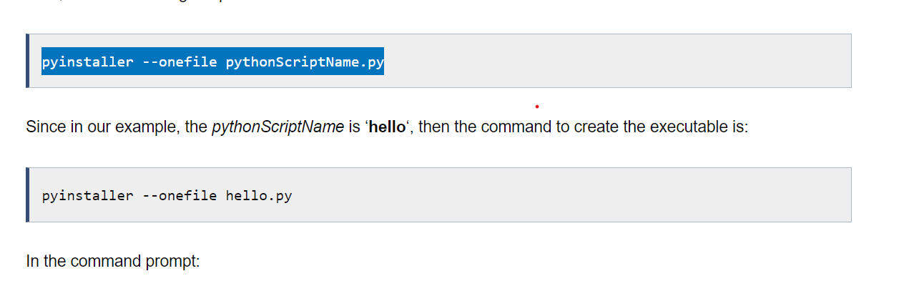

widget